Chapter 13, Solution 72.

(a) Consider just one phase at a time.
1:n
c
b
a
C

20MVA
Load
B
A

n = V_{L}/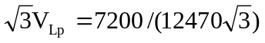 = 1/3

(b) The load carried by each transformer is 60/3 = 20 MVA.

Hence I_{Lp} = 20 MVA/12.47 k = 1604 A

I_{Ls} = 20 MVA/7.2 k = 2778 A

(c) The current in incoming line a, b, c is

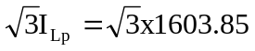 = 2778 A

Current in each outgoing line A, B, C is
2778/(n) = 4812 A

